**Mini Crab Cakes with Remoulade Sauce – 1 recipe makes 60**

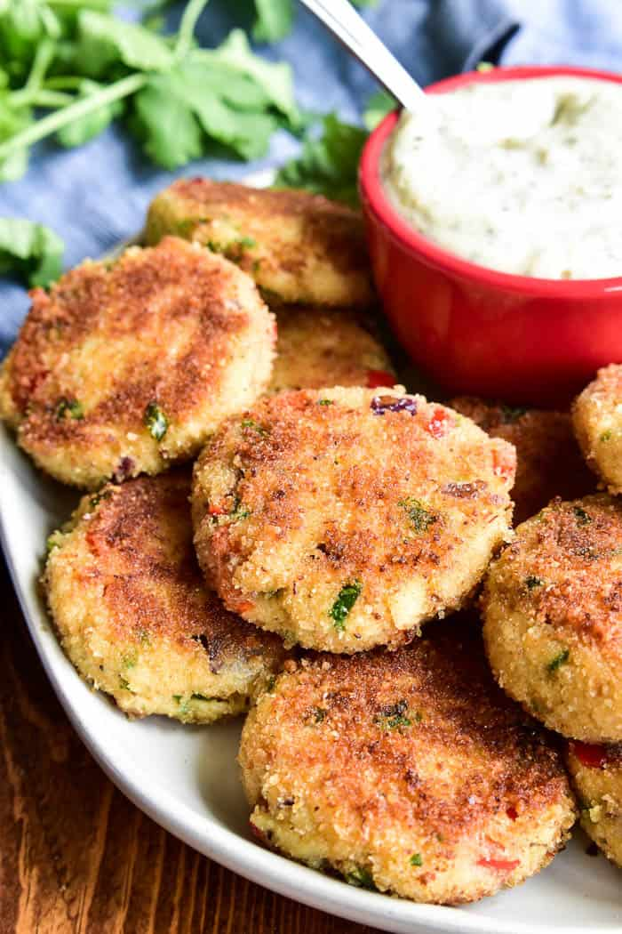

4 T. unsalted butter

4 scallions, first two inches from root end, minced

2 ribs celery, minced

3 cloves garlic, minced

5 cans crab meat, drained, save the liquid in bag/bowl with teacher

5 eggs, ***lightly beaten together***

4 t. lemon juice

4 T. whole grain mustard

2 T. dried parsley, crushed in hands

1 c. bread crumbs

10 T. oil for frying

**Preparation:**

1. Line 4 baking sheets with parchment paper and spray generously with cooking spray.

**Directions:**

1. In a medium skillet, heat the butter. Add the scallions, celery, and garlic, and sauté over medium heat until vegetables are soft, about 3-4 minutes.
2. In a large bowl, combine cooked vegetables with drained crab, beaten eggs, lemon juice, mustard, and parsley. Add bread crumbs and stir gently to combine.
3. Divide the mixture into 4 equal parts, each person then will make 15 mini crab cakes as directed below:
   1. Using a spoon, each person forms the crab mixture into 15 equally-sized crab cakes.
   2. Flatten crab cakes to ½ inch thick.
4. To cook, pour 2 T. oil into electric skillet and heat at 275˚. Brown 8 crab cakes on first side for about 2-3 minutes, then turn and cook for about 2-minute more on second side. Crab cakes should be golden brown on both sides. Remove from oil and drain on paper towels.
5. Place cooked crab cakes on parchment-lined baking sheet just so they are NOT touching, cover with plastic wrap. ***COUNT ALL PIECES AND TELL TEACHER THE NUMBER WHEN YOU TURN THEM IN.***

**Remoulade Sauce *(ONLY MAKE ONE RECIPE):***

2/3 c. mayonnaise

2 scallions, first two inches from root end, minced

1 T. dried parsley, crushed

1 T. dill, crushed

1 t. lemon juice

2 T. horseradish

4 T. whole grain mustard

1 T. ketchup

1 t. Worcestershire sauce

1 T. paprika

1/8 t. pepper

Dash Tabasco sauce

Stir all ingredients in a bowl until combined. Divide into 2 white bowls and cover with plastic wrap.

**THAT NIGHT**: Warm up crab cakes at 325˚F for 10-15 minutes. Plate up on 3 platters with sauce in the center.

**Buffalo Turkey Meatballs – 1 recipe make 125 pieces**

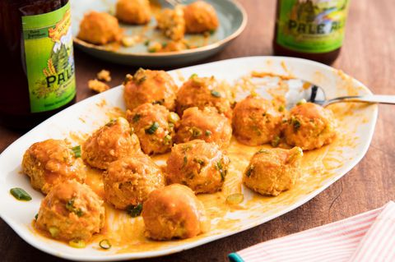

**Ranch Dip or Dressing Recipe**

½ c. mayonnaise

¼ c. sour cream

¼ t. dried chives, crushed to release flavor

¼ t. dried parsley, crushed to release flavor

¼ t. dried dill, crushed to release flavor

1/8 t. garlic powder

1/8 t. onion powder

Pinch salt and pepper

In a small bowl, whisk together the mayonnaise and sour cream.

Stir in all the spices until well blended.

Refrigerate for at least an hour or overnight to develop flavor.

To make into dressing, add 2-4 T milk to thin to desired consistency.

Top of Form

Bottom of Form

## Ingredients

2 ½ lbs. ground turkey

1 small onion, finely minced

3 cloves garlic, finely minced

½ c. dried parsley, crushed

¼ c. + 2 T. crumbled blue cheese

3 pieces celery, cut into ¾ inch pieces

4 Tbsp. butter

1 cup FRANK'S RedHot® [Original Cayenne Pepper Sauce](https://www.franksredhot.com/products/original-cayenne-pepper-sauce)

Homemade ranch dressing – see recipe in box

**Day time directions**

1. Person 1: Line a large baking sheet with parchment paper. Brush with olive oil.
2. Person 2: MELT the butter in a large pot. Add the Frank's RedHot Sauce and whisk to combine. REMOVE FROM HEAT right away to start to cool, otherwise, you’ll start to cook the meatballs prematurely.
3. Person 3: MIX the chicken with the onion, garlic, parsley, blue cheese. Divide the mix into 5 equal portions.
4. Person 4: Meanwhile, wash, dry and cut the celery into ¾ inch pieces. Place in a salad bowl and label and wrap.
5. EVERYONE: Each portion gets formed into 25 meatballs, no bigger than 1 inch. FORMS 125 meatballs total.
6. Dip meatballs into sauce and then place meatballs on parchment lined baking sheet, closely, but not touching. WRAP baking sheets with plastic and label as Buffalo Turkey Bites. Give to teacher. ***COUNT ALL PIECES AND TELL TEACHER THE NUMBER WHEN YOU TURN THEM IN.***

**Night time directions:**

1. PREHEAT oven to 350°F.
2. Bake until the meatballs are cooked through about 20 minutes, turning the meatballs over halfway through baking.
3. Using a toothpick, DIP each meatball HALFWAY into the ranch dressing and place on serving platter with toothpick pointing up.

**Sesame Chicken Bites – 1 recipe makes ~100 pieces**

|  |  |  |  |  |  |  |  |  |  |  |  |  |  |  |  |  |  |  |  |  |  |  |  |  |  |  |  |  |
| --- | --- | --- | --- | --- | --- | --- | --- | --- | --- | --- | --- | --- | --- | --- | --- | --- | --- | --- | --- | --- | --- | --- | --- | --- | --- | --- | --- | --- |
| |  |  |  |  |  |  |  |  |  |  |  |  |  |  |  |  |  |  | | --- | --- | --- | --- | --- | --- | --- | --- | --- | --- | --- | --- | --- | --- | --- | --- | --- | --- | | **INGREDIENTS**   |  | | --- | | ***For the Chicken Bites:***  3 boneless, skinless chicken breasts | | 1 ½ c. flour | | ½ t. salt | | 5 large eggs | | ¾ c. water | | 4 c. fine panko crumbs | | 1 c. sesame seeds | | 1 t. garlic powder | |  | |  | | 3 T. ***PER COOKING BATCH*** oil | |  | |  | |  | |  | |  | |  | | | |  | | --- | | ***For the Chinese Mustard Sauce:*** 1/4 c. mayonnaise | | 2 T. Hot Chinese mustard | | 2 T. Dijon mustard | | 1 T. crystallized ginger, minced | | ***For the Teriyaki Sauce:*** 1/4 c. rice wine vinegar | | 1/4 c. Hoisin sauce | | 3 scallions, white and 1 inch of green part only, minced | | 2 cloves garlic, minced | | 1 T. brown sugar |   Image result for sesame chicken bites |
| |  | | --- | | ***FOR THE CHICKEN BITES:*** | | 1. **Line 4 baking sheets with parchment, then spray cooking spray on the parchment paper.** 2. Trim chicken breasts of any fat, butterfly (cut in half horizontally), and cut each ½ chicken breast into 20-25 equal, bite-sized pieces. 3. In shallow dish, whisk together flour and salt. 4. In another shallow dish, whisk together eggs and water. 5. In third shallow dish, mix together garlic powder, crumbs and sesame seeds. | | 1. Form an assembly line to have each person do the following steps in order: 2. Person 1 - Dredge chicken piece in flour, coating all sides. 3. Person 2 - Dip chicken in egg. 4. Person 3 - Roll chicken in crumb mixture to coat well. | | 1. Person 4 – Place coated chicken pieces onto parchment lined, cooking spray coated baking sheets close together but NOT touching, once the tray is full, wrap with plastic and give to teacher for later. 2. Wrap chicken covered baking sheets with plastic wrap and label. Give to teacher to be cooked later. ***COUNT ALL PIECES AND TELL TEACHER THE NUMBER WHEN YOU TURN THEM IN.*** | | ***FOR THE DIPPING SAUCES:***   1. Mix together all ingredients for each sauce in two separate custard dishes. 2. Cover and refrigerate until ready to serve with chicken.   **THAT NIGHT**: Cook chicken at 375˚F, about 10-15 minutes or until hot. Switch trays in oven half way through baking. Plate up on platters with sauces in the center. Put a toothpick in each one. | | |

**Walking Caprese Salads – 1 recipe makes 98**

2 blocks mozzarella cheese

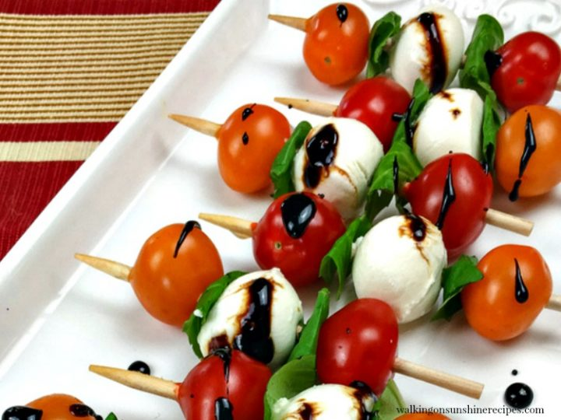4 pints containers grape tomatoes, washed and dried, cut in half

100 basil leaves, torn in half

Balsamic vinegar reduction for drizzle before serving.

Wooden skewers

1. **SOAK the short wooden sticks in water while preparing all the other items.**
2. Cut the blocks of mozzarella into 3 layers of 4x4” cubes, you should have 48 from each block.
3. Thread the toothpick with the following: one half tomato piece, half a basil leaf, cheese cube, half a basil leaf, and then another half tomato piece.
4. Place decoratively on long white platter and wrap with plastic. Give to teacher for later. ***COUNT ALL PIECES AND TELL TEACHER THE NUMBER WHEN YOU TURN THEM IN.***

**THAT NIGHT**: Before serving, drizzle with Balsamic vinegar reduction made by teacher.

***Vegetarian Flatbread***

**1 recipe makes ~25**

**Ingredients:**

2 ½ c. all-purpose flour 1 ½ t. sugar

½ t. salt 1 t. + 1/8 teaspoon instant yeast

2 T. olive oil ¾ c. hot water from teacher (110˚-120˚)

2 T. cornmeal for dusting

4 leaves of kale torn into pieces with stems removed ½ red bell pepper diced

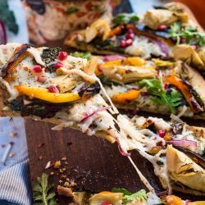4-5 artichoke hearts, chopped

**Preparation:**

Preheat oven 425°F. Sprinkle cornmeal over sheet pan evenly.

**Day Directions:**

1. Stir together the flour and salt in a large bowl. Set aside.
2. In the large stand mixer bowl, place the yeast and sugar.
3. Add the hot water from the teacher to the stand mixer bowl and immediately stir.
4. Let sit for 5 minutes until frothy/foamy.
5. Turn the mixer on low speed and add in the oil.
6. Then add the flour slowly to the mixer and let mix for 5 to 7 minutes or until the dough is smooth and the ingredients are evenly distributed. The dough should clear the sides of the bowl but stick to the bottom of the bowl. (If the dough is too wet and doesn't come off the sides of the bowl, sprinkle in some more flour just until it clears the sides. If it clears the bottom of the bowl, but there are dry parts at the bottom, dribble in a teaspoon or two of cold water.) The finished dough will be springy, elastic, and tacky.
7. Remove the dough from the mixer bowl and knead on a floured counter top for 7-10 minutes or until dough is soft and elastic.
8. Let dough rest 10 minutes.
9. After rest, stretch out to fit sheet pan.
10. Brush with olive oil.
11. Bake until nicely browned and crispy, about 10-13 minutes. Watch the pizza to be sure it doesn’t burn.
12. WHILE THE PIZZA BAKES, dice the red pepper, chop the artichoke hearts, and tear up the kale leaves. Wrap each ingredient in plastic wrap and label, bring to teacher.

Ingredients

1 pizza crust

½ c. pesto sauce

½ c. Mozzarella cheese, shredded

1 t. dried oregano, crushed

**Night time directions:**

1. Preheat oven to 375º.
2. Spread baked pizza crust with pesto. Sprinkle with cheese, kale, roasted bell pepper, and artichoke hearts.
3. Cook 5-7 minutes until warmed through and flatbread is crispy.
4. Cut into 1 ½ inch wide by 3-inch long strips. Place on serving platter. Should get about 25 pieces. ***COUNT ALL PIECES AND TELL TEACHER THE NUMBER WHEN YOU TURN THEM IN.***

**Crust-less Spinach Mini Quiches – 1 recipe makes 48**

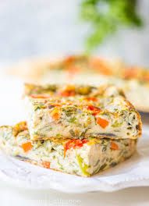**Ingredients**

6 large eggs, beaten

1 ½ c. heavy cream

1 t. salt

1 t. pepper

1 16-oz bag frozen spinach

1 ½ c. shredded Swiss cheese

**Day 1 Directions**

1. Preheat oven to 350ᵒ. Line 9 X 13 inch baking pan with parchment paper.
2. In a large bowl, using the whisk, beat the eggs until thoroughly combined.
3. Into the eggs, whisk in the cream, salt, and pepper.
4. Pour the egg mixture into the lined pan.
5. Layer the spinach in next, the sprinkle the cheese on top.
6. Bake for 20 minutes, then check to see if it’s done in the center, no wiggle.  If not, add 3 minutes and check again.
7. Remove from oven when cooked and set whole pan on a cooling rack.
8. After cooling for about 10 minutes, lift up using the parchment paper and set the egg mixture onto the cooling rack to continue cooling.
9. Wrap in plastic to chill and firm up.
10. Give to teacher for next day’s work.

**Day 2 Directions**

Remove from fridge, cut into 48 squares, 6 x 8 cuts, place on parchment lined baking sheets, separated a little bit, wrap in plastic, and give to teacher.

***COUNT ALL PIECES AND TELL TEACHER THE NUMBER WHEN YOU TURN THEM IN.***

**NIGHT Directions**:  Reheat at 325ᵒ for 15-20 minutes or until warmed through again. Place on tray and put a toothpick in each one.

**Brownie Bites – 1 recipe makes 48**

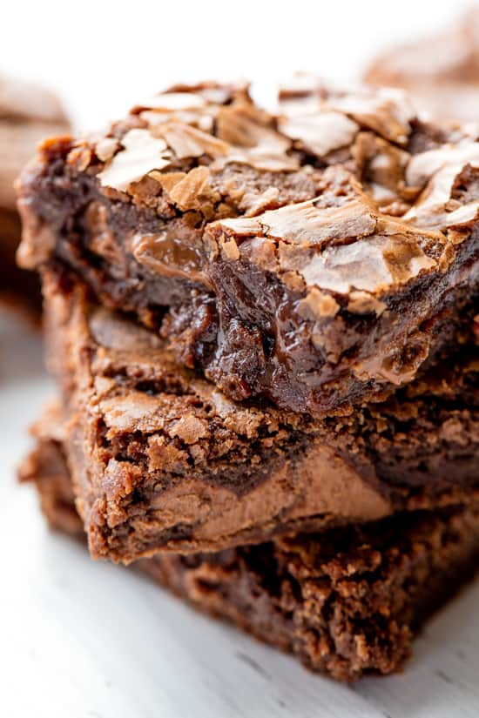**Brownie Ingredients**

4 whole 1-ounce Squares Unsweetened Chocolate

2 sticks Butter, Softened (but Not Room Temperature)

2 c. Sugar

4 Eggs

1 T. Vanilla Extract

1 ¼ c. Flour

1 c. Semi-sweet Chocolate Mini Chips

**Day 1 Directions**

1. Preheat oven to 350 F. Line a 13 X 9 inch baking pan with parchment paper, going longways.
2. Melt 4 ounces unsweetened chocolate ***(Not the chocolate chips)*** in a saucepan over ***LOW*** heat. Once it’s melted, set it aside for 5 minutes, allowing it to cool. Chocolate should not be warm!
3. Using your stand mixer, cream butter and sugar until fluffy.
4. Beat in the eggs two at a time.
5. With stand mixer on low, drizzle in the cooled chocolate. Mix until just combined. Next, add in vanilla extract and mix until combined.
6. Add flour and mix until just combined. Scrape sides and bottom of bowl and mix for five more seconds.
7. Add chocolate chips and mix for just a few seconds on low, until they’re incorporated.
8. Fill the lined baking pan with the batter. USE ALL THE BATTER, NO WASTE.
9. Bake for 20 to 25 minutes, or until set. Allow brownies to cool completely in the pan, then lift out carefully to avoid breaking apart.
10. Wrap in plastic wrap, give to teacher to refrigerate.

**Day 2 Directions:**

1. Remove from fridge, cut in a 6 x 8 pattern to make 48 pieces, and place on decorative platter. Wrap platter in plastic, place back in fridge. ***COUNT ALL PIECES AND TELL TEACHER THE NUMBER WHEN YOU TURN THEM IN.***

**THAT NIGHT:** Unwrap and serve.

**Fruit Kabob Tray - 1 recipe makes ~100 Kabobs**

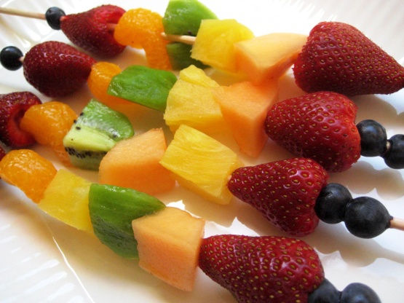**For Fruit Kabobs:**

1 cantaloupe, cut into 1 inch pieces

1 pineapple, cut into 1 inch pieces

1 pkg. red grapes, washed and dried

1 pkg. strawberries, washed, dried and cut in half

1. **SOAK the wooden sticks in water while preparing all the other items.**
2. **Prepare a large round platter with a doily in the center, then wrap entire tray in plastic wrap.**
3. In 4 LARGE bowls each, combine 4 T. lemon juice with 4 cups of water.
4. Remove every grape from stem, wash with water and dry with paper towels.
5. Wash, peel and core/remove seeds all fruit assigned to your group.
   1. **Person 1:** Pick, remove from stem, wash and dry all grapes, place in a bowl.
   2. **Person 2:** Cut cantaloupe into **1 inch cubes** and immediately place in lemon water bowl until all fruit is cut and in the bowl.
   3. **Person 3:** Cut pineapple into **1 inch cubes** and immediately place in lemon water bowl until all fruit is cut and in the bowl.
   4. **Person 4:** Wash, dry and cut strawberries in ½ place in bowl.
6. Thread one piece of each fruit on the skewer, ***arrange all the same way***, layer fruit kabobs on the tray evenly in a radiant circle pattern, so you have 50 on one tray and 50 on the other, all the handle-ends are on the outside edge.
7. Sprinkle fruit with Fruit Fresh.

Wrap the trays tightly with plastic wrap and give both trays to teacher. ***COUNT ALL PIECES AND TELL TEACHER THE NUMBER WHEN YOU TURN THEM IN.***

**THAT NIGHT**: Unwrap plastic and set out on each of the table.